TEAM2025 Conference Timetable
Oct.15, Wed | Time | Oct.16, Thu | Time | Oct.17, Fri | Oct.18, Sat
Registration  (1F lobby) | 08:50-09:30 | Late Registration  (1F lobby) | 08:50-09:30 | Keynote Lecture 3  (Room 201) | Cultural Tour
Registration  (1F lobby) | 09:30- 09:50 | Opening Ceremony  (Room 201) | 09:30-10:10 | Keynote Lecture 4  (Room 201) | Cultural Tour
Registration  (1F lobby) | 09:50-10:30 | Conference Photo+Coffee Break  (1F lobby) | 09:30-10:10 | Keynote Lecture 4  (Room 201) | Cultural Tour
Registration  (1F lobby) | 09:50-10:30 | Conference Photo+Coffee Break  (1F lobby) | 10:10-10:40 | Coffee Break  (1F lobby) | Cultural Tour
Registration  (1F lobby) | 10:30- 11:10 | Keynote Lecture 1  (Room 201) | 10:40-12:20 | Technical Session  CAD/CAM/CIM in Shipbuilding  (Room 103)  Structural Design Criteria II  (Room 104)  Offshore Structures  (Room 202) | Cultural Tour
Registration  (1F lobby) | 11:10- 11:50 | Keynote Lecture 2  (Room 201) | 10:40-12:20 |  | Cultural Tour
Registration  (1F lobby) | 11:50- 13:40 | Lunch  (Canteen) | 12:20- 13:40 | Lunch  (Canteen) | Cultural Tour
Registration  (1F lobby) | 13:40- 15:20 | Technical Session  Structural Performance I  (Room 103)  Cruise ship and Yacht I  (Room 104)  Structural Response I  (Room 202) | 13:40- 15:20 | Technical Session  Structural Performance III  (Room 103)  Noise and Vibration  (Room 104)  Structural Response II  (Room 202) | Cultural Tour
Registration  (1F lobby) | 15:20- 15:40 | Coffee Break  (1F lobby) | 15:20- 15:40 | Coffee Break  (1F lobby) | Cultural Tour
Registration  (1F lobby) | 15:40- 17:20 | Technical Session  Structural Performance II  (Room 103)  Structural Design Criteria I  (Room 104)  External / Internal Loads I  (Room 202) | 15:40- 17:20 | Technical Session  Production Technique  (Room 103)  Cruise ship and Yacht II  (Room 104)  External / Internal Loads II  (Room 202) | Cultural Tour
Buffet  (canteen) | 17:30-19:30 | Buffet  (canteen)  IOC/ITC meeting  (Room 102) | 17:20-17:50 | Closing Ceremony  (Room 201)
Buffet  (canteen) | 17:30-19:30 | Buffet  (canteen)  IOC/ITC meeting  (Room 102) | 18:30-21:00 | Banquet on Yacht

Conference Overall Schedule
Date | Time | Session / Activity | Location
Oct.15 | 14:30-18:00 | Registration | 1F Lobby
Oct.15 | 18:00-19:30 | Buffet | Canteen
Oct.16 | 08:50-09:30 | Late Registration | 1F Lobby
Oct.16 | 09:30-09:50 | Opening Ceremony | Room 201
Oct.16 | 09:50-10:30 | Conference Photo+Coffee Break | 1F Lobby
Oct.16 | 10:30-11:10 | Keynote Lecture 1 | Room 201
Oct.16 | 11:10-11:50 | Keynote Lecture 2 | Room 201
Oct.16 | 11:50-13:40 | Lunch | Canteen
Oct.16 | 13:40-17:20 | Technical Session | Room 103、104、202
Oct.16 | 17:30-19:30 | Buffet | Canteen
Oct.16 | 17:30-19:30 | IOC/ITC meeting | Room 102
Oct.17 | 08:50-09:30 | Keynote Lecture 3 | Room 201
Oct.17 | 09:30-10:10 | Keynote Lecture 4 | Room 201
Oct.17 | 10:40-12:20 | Technical Session | Room 103、104、202
Oct.17 | 12:20-13:40 | Lunch | Canteen
Oct.17 | 13:40-17:20 | Technical Session | Room 103、104、202
Oct.17 | 17:20-17:50 | Closing Ceremony | Room 201
Oct.17 | 18:30-21:00 | Banquet on Yacht
Registration and sessions venue: Conference center, Wuhan University of Technology (Mafangshan campus)
Address: 122 Luoshi Road, Wuhan 430070, Hubei, China
Keynote Lecture
2025.10.16 AM Room 201
Time | No. | Report | Chair
10:30-11:10 | KY01 | Cruise engineering promotes high-quality development of China's shipbuilding industry  Gang Chen, Guowei Yi, Jianing Li | Bin Liu
11:10-11:50 | KY02 | Research and application of Chinese inland electric-drived vessels  Zhiyong Pei, Fei Long, Yuhan Kang, Jing Chen | Bin Liu
2025.10.17 AM Room 201
Time | No. | Report | Chair
08:50-09:30 | KY03 | Green and intelligent shipbuilding, building green and intelligent ships  Lei Zhang, Qiang Zhang, Xianglong Jiang | Weicheng Cui
09:30-10:10 | KY04 | Chinese solution for zero-carbon shipping: CATL battery technology powering the electric revolution in vessels  Dongze Lv, Yiyi Su | Weicheng Cui

Parallel Session
2025.10.16 PM Room 103
Time | Session | No. | Report | Chair
13:40-14:00 | Structual Performance I | SP01 | Analysis of the stress-strain state of ship structures under complex loading and stress concentration  Konstantin A Molokov, Valery V Novikov | Tetsuo Okada, Hongchang Zhou
14:00-14:20 | Structual Performance I | SP02 | Multiscale fatigue prediction model for welded joints of ship structures considering multiple crack problem  Hongchang Zhou, Masao Kinefuchi, Kazuki Shibanuma, Yasuhito Takashima | Tetsuo Okada, Hongchang Zhou
14:20-14:40 | Structual Performance I | SP03 | Analysis of crack opening and closing behavior with crack propagation simulation using elasto-plastic FEM  Ginga Hayakawa, Yasumi Kawamura, Tetsuo Okada, Naoya Hirata | Tetsuo Okada, Hongchang Zhou
14:40-15:00 | Structual Performance I | SP04 | Automatic estimation of stress concentration factor and stress gradient of weld bead using measurement data and finite element analysis  Minato Akahori, Mao Yokoyama, Tetsuo Okada, Yasumi Kawamura, Ginga Hayakawa | Tetsuo Okada, Hongchang Zhou
15:00-15:20 | Structual Performance I |  |  | Tetsuo Okada, Hongchang Zhou
15:40-16:00 | Structural Performance II | SP05 | Assessment of structural superiority using gradient of strain energy calculated in FE analysis  Kazuya Watari, Kimihiro Toh, Daisuke Yanagihara | Jung Min Sohn, Wulong Hu
16:00-16:20 | Structural Performance II | SP06 | Research on the influence of bionic leading edge protrusion on propeller cavitation  Sibo Xie, SiYuan Zuo, Wulong Hu, Haishan Xia | Jung Min Sohn, Wulong Hu
16:20-16:40 | Structural Performance II | SP07 | A study on the effect of lateral deformation of asymmetrical stiffeners on the bending strength  Aoi Taniguchi, Tetsuo Okada, Yasumi Kawamura, Ginga Hayakawa | Jung Min Sohn, Wulong Hu
16:40-17:00 | Structural Performance II | SP08 | Study on fatigue crack propagation of heavy-thick T-joints improved by pneumatic impact treatment  Xipeng Chen, Naoki Osawa, Sherif Rashed, Takaaki Takeuchi, Donghui Ma, Jun Okada, Masahito Honnami | Jung Min Sohn, Wulong Hu
17:00-17:20 | Structural Performance II | SP11 | Numerical analysis of curvature effects on the elastic modulus of CFRP composites under tensile loading  Jin Hyung Kim, Hyung Gi Lee, Won Seok Choi, Jwa Yun Kim, Jung Min Sohn | Jung Min Sohn, Wulong Hu
2025.10.16 PM Room 104
Time | Session | No. | Report | Chair
13:40-14:00 | Cruise ship and Yacht I | CY01 | Research on bending efficiency of the superstructure for cruise ships  Bin Yang, Zhiyong Pei, Zhongyuan Ma, Chuanjun Chen | Guangwu Liu，Bin Yang
14:00-14:20 | Cruise ship and Yacht I | CY02 | A study of superstructure-by-superstructure collapse characteristics of large cruise ships  Chuanjun Chen, Bin Yang, Zhiyong Pei | Guangwu Liu，Bin Yang
14:20-14:40 | Cruise ship and Yacht I | CY03 | System requirements engineering with MBSE tool M-design in marine project  Dongsan Yan, Guangwu Liu, Yihao Du, Liuming Yang | Guangwu Liu，Bin Yang
14:40-15:00 | Cruise ship and Yacht I | CY04 | Efficient prediction of T-foil hydrodynamic performance using CFD and surrogate modeling  Yongfeng Cheng, Mengyao Xing, Wulong Hu | Guangwu Liu，Bin Yang
15:00-15:20 | Cruise ship and Yacht I | CY05 | A Survey of Deep Learning Methods for Predicting Ship Structural Motion Responses  Mengyao Xing, Yongfeng Cheng, Wulong Hu | Guangwu Liu，Bin Yang
15:40-16:00 | Structural Design Criteria I | SDC01 | Navigating the costs-implementing fire safety standards for EV-carrying ferry in indonesia  Wanginingastuti Mutmainnah, Ayumi Putri Varadita, Muhamad Rizqi Fitra Hariadi, Defi Rizki Mauliani, Adam Perdana Putera, Fivid Rivantoro, Muhammad Arif Kurniawan | Huabin Liu
16:00-16:20 | Structural Design Criteria I | SDC02 | Formulation and numerical solution of the problem of optimization of ship hull structures  Viktor G Bugaev, Vladislav М Kashaev, Maksim V Kitaev | Huabin Liu
16:20-16:40 | Structural Design Criteria I | SDC03 | Decomposition of the ship control function into a trigonometric series to find the elements of motion when keeping a course or trajectory  Sergei A Ogai, Michael V Voyloshnikov, Alexey S Ogai, Roman A Belogor | Huabin Liu
16:40-17:00 | Structural Design Criteria I | SDC04 | A study on generative aircraft shape design with voxel-based generative adversarial networks (GANs)  Tetsu Ma , Yasumi Kawamura, Van Cong Tai , Tetsuo Okada, Ginga Hayakawa | Huabin Liu
17:00-17:20 | Structural Design Criteria I | SDC05 | Experience of creating crab fishing vessels in Russia  Konstantin Viktorovich Gribov | Huabin Liu
2025.10.16 PM Room 202
Time | Session | No. | Report | Chair
13:40-14:00 | Structural Response I | SR01 | Numerical study on dynamic response and slamming pressure of bow flare using ICFD method  Kenta Fukui, Kimihiro Toh, Shigeyuki Hibi, Yasuhira Yamada, Daisuke Yanagihara | Kazuhiro Iijima, Yiwen Wang
14:00-14:20 | Structural Response I | SR02 | CFD-FEM coupled analysis of elastic alternative fuel tank structural response under sloshing loads on the upper deck of conventional ships  Binyang Xie, Masafumi Yamamoto, Kazuhiro Iijima, Sumit Kumar Pal | Kazuhiro Iijima, Yiwen Wang
14:20-14:40 | Structural Response I | SR03 | A method to estimate the global springing responses of a containership and nonlinear effects in regular mild oblique seas  Haixing Wang, Xiaofei Wu, Xu Zhai, Yuqi Xiang, Zixuan Zhou | Kazuhiro Iijima, Yiwen Wang
14:40-15:00 | Structural Response I | SR04 | Numerical investigation of flooded bulk carrier collapse in waves using a CFD–FEA coupling method  Jian Duan, Zhiyong Pei | Kazuhiro Iijima, Yiwen Wang
15:00-15:20 | Structural Response I | SR10 | Collapse behavior and ultimate strength of ring-stiffened cylindrical shell subjected to combined bending and axial compression  Daisuke Takenaka, Kimihiro Toh, Daisuke Yanagihara | Kazuhiro Iijima, Yiwen Wang
15:40-16:00 | External and/or Internal Loads I | EIL01 | Investigation on internal pressure on inclined rectangular box filled with glass beads based on DEM analysis  Seiya Fujiwara, Kimihiro Toh, Daisuke Yanagihara | Liuming Yang
16:00-16:20 | External and/or Internal Loads I | EIL02 | Load mapping of CFD-derived overpressure data for finite element analysis  Gi Ryeol Park, Harris Nubly, Jung Min Sohn | Liuming Yang
16:20-16:40 | External and/or Internal Loads I | EIL03 | The impact of lubricating fluids on the drag characteristics of liquid-infused surfaces  Xinmeng Yang, Shuai Wang, Liuming Yang | Liuming Yang
16:40-17:00 | External and/or Internal Loads I | EIL04 | Study on deformation and failure characteristics of pitted stiffened panels under impact loading  Lei Ao, Yaqi Cheng, Zhiyong Pei | Liuming Yang
17:00-17:20 | External and/or Internal Loads I | EIL05 | Sensitivity analysis of design parameters on the ultimate strength of wind turbine tower structure under lateral load  Won Seok Choi, Jung Min Sohn, Sang Jin Kim | Liuming Yang

2025.10.17 AM Room 103
Time | Session | No. | Report | Chair
10:40-11:00 | CAD/CAM/CIM in Shipbuilding | CAD01 | Estimation of stress concentration factor and stress gradient of weld beads in ship structures using smartphone-based 3D scanning and machine learning  Mao Yokoyama, Tetsuo Okada, Yasumi Kawamura, Ginga Hayakawa | Runlin Gan
11:00-11:20 | CAD/CAM/CIM in Shipbuilding | CAD02 | An XML-parsing-based approach for interactive visualization of MBSE class diagrams  Yihao Du, Guangwu Liu，Dongsan Yan | Runlin Gan
11:20-11:40 | CAD/CAM/CIM in Shipbuilding | CAD03 | Research on full data chain simulation of intelligent pipe production line for smart shipbuilding  Jilin Liu, Guangwu Liu, Xingzhi Xu, Xiaochuan Wang, Chenhao Zhu, Jia Zhang | Runlin Gan
11:40-12:00 | CAD/CAM/CIM in Shipbuilding | CAD04 | Progressive collapse behaviour and accumulation plasticity of hull girder on wave loading  Sirui Zhuo , Qingning Yuan , Zhiyong Pei | Runlin Gan
12:00-12:20 | CAD/CAM/CIM in Shipbuilding | CAD05 | Fracture modeling of composite materials using ordinary state-based peridynamics  Hanlin Wang, Lei Ju, Satoyuki Tanaka, Erkan Oterkus | Runlin Gan
2025.10.17 AM Room 104
Time | Session | No. | Report | Chair
10:40-11:00 | Structural Design Criteria II | SDC06 | Proposal of ROM for Elastic Response of a Panel under Bow-Flare Slamming Impact and Its Validation  Yuta Nishimura, Binyang Xie, Kei Sugimoto, Kazuhiro Iijima | Bin Liu, Jie Li
11:00-11:20 | Structural Design Criteria II | SDC07 | Research on reduced order model method considering the dynamic responses of structures  Pengfei Wang, Yiwen Wang, Hantao Zhang, Xiangshao Kong, Cheng Zheng, Yuran Li, Yiming Zan | Bin Liu, Jie Li
11:20-11:40 | Structural Design Criteria II | SDC08 | Construction of the agent model for typical hull structural strength response based on GA-PSO-BP neural network  Yuhan Kang, Zhiyong Pei, Weiguo Wu | Bin Liu, Jie Li
11:40-12:00 | Structural Design Criteria II | SDC09 | Study on machine learning-based control of air injection rate for bubble drag reduction  Ziyin Li, Zhiyong Pei, Bin Liu | Bin Liu, Jie Li
12:00-12:20 | Structural Design Criteria II | SDC10 | Research of optimization on the air flow rate for bubble reduction resistance utilizing a BP neural network and genetic algorithm  Yingqi Pei, Yanan Zhou, Bing Yang | Bin Liu, Jie Li
2025.10.17 AM Room 202
Time | Session | No. | Report | Chair
10:40-11:00 | Offshore Structures | OSP01 | Numerical study on wear characteristic for load and frequency of mooring chain for floating offshore structures  Yuko Onishi, Takaaki Takeuchi | Lei Ao
11:00-11:20 | Offshore Structures | OSP02 | Research on survey standards of positioning pile-moored pontoons based on structural safety assessment  Ji Zhou, Yuanjie Zhu, Xinsheng Huang | Lei Ao
11:20-11:40 | Offshore Structures | OSP03 | Fatigue strength assessment application of jack-up rigs platform  Hung Chien Do, Tuan Vu Le, Ngoc Thuan Bui | Lei Ao
11:40-12:00 | Offshore Structures | OSP04 | Machine learning model for fatigue crack growth prediction in marine structural steel under high-low frequency superimposed loading  Guozhao Li, Kuilin Yuan, Yichen Jiang | Lei Ao
12:00-12:20 | Offshore Structures |  |  | Lei Ao
2025.10.17 PM Room 103
Time | Session | No. | Report | Chair
13:40-14:00 | Structual Performance III | SP10 | Study on fatigue assessment of ore carrier based on equivalent wave probability (EWP) concept  Aoba Yamaguchi, Takaaki Takeuchi, Naoki Osawa, Shinichi Hirakawa, Yoshitaka Kawajiri, Tomomi Yoshida | Zhongyuan Ma,
14:00-14:20 | Structual Performance III | SP12 | Structural collapse characteristics of flat-type river-sea-going ship in waves  Qingning Yuan, Zhiyong Pei, Weiguo Wu | Zhongyuan Ma,
14:20-14:40 | Structual Performance III | SP13 | Research on the remaining limitstrength of ship hull structures under fire  Weihao Zhao, Zhiyong Pei, Zhongyuan Ma | Zhongyuan Ma,
14:40-15:00 | Structual Performance III | SP15 | Marine corrosion and models for determining the corrosion in ship structures  Vu Van Tuyen, Cu Huy Chinh | Zhongyuan Ma,
15:00-15:20 | Structual Performance III | SP17 | Hive-net intelligence: a hierarchical-decentralized control framework for UAV swarm operations in maritime environments  Chenwei Hu, Mengyao Zhang, Haiyu Zhang | Zhongyuan Ma,
15:40-16:00 | Production Technique | PT01 | Sea transportation development project: innovative solutions of the Russian shipping company to strengthen trade relations with Asia  Sovin Dmitry Antonovich, Slargorodskaya Alexandra Vladimirovha | Guangwu Li， Zhengyi Zhang
16:00-16:20 | Production Technique | PT02 | Long-term vessel distribution forecasting in east and southeast asia: a case study on capesize bulk carriers  Balqis Shintarahayu, Takara Maruoka, Naokazu Taniguchi, Yujiro Wada, Kunihiro Hamada | Guangwu Li， Zhengyi Zhang
16:20-16:40 | Production Technique | PT03 | Machine learning-based prediction of welding-induced deformation in DH36 steel T-joints fabricated via continuous simultaneous double-sided fillet welding  Ying Tang, Zhengyi Zhang, De Xie | Guangwu Li， Zhengyi Zhang
16:40-17:00 | Production Technique | PT04 | Fire safety readiness assessment of indonesian ferry on transporting electrical vehicles  Ayumi Putri Varadita, Muhamad Rizqi Fitra Hariadi, Adam Perdana Putera, Fivid Rivantoro,Wanginingastuti Mutmainnah, Mohammad Arif Kurniawan | Guangwu Li， Zhengyi Zhang
17:00-17:20 | Production Technique | PT05 | Trajectory prediction of drifting unmanned surface vehicle by multi-step extended kalman filter  Jae Gwan Kim, Sung Min Eom, Dong Heon Yang, Seungha Lee, Kookhyun Kim, Dae Seung Cho, Yun Ho Shin | Guangwu Li， Zhengyi Zhang
2025.10.17 PM Room 104
Time | Session | No. | Report | Chair
13:40-14:00 | Noise and Vibration | NVP01 | Numerical simulation of drag and noise reduction mechanisms for flow around a circular cylinder with grooved surfaces  Siyuan Zuo，Wulong Hu | Wulong Hu
14:00-14:20 | Noise and Vibration | NVP02 | Acoustic characteristics of the surface corrugated groove structure on underwater vehicles  Haishan Xia, Wulong Hu, Sibo Xie, Siyuan Zuo | Wulong Hu
14:20-14:40 | Noise and Vibration | NVP03 | Analysis of soundscape comfort design of open areas in large cruise ship  Haolong Wu, Changxue Pan | Wulong Hu
14:40-15:00 | Noise and Vibration | NVP04 | Wake characteristics prediction of a floating wind turbine  Chun Liang Tan, Tsung Yu Hsiao, Shiu Wu Chau | Wulong Hu
15:00-15:20 | Noise and Vibration |  |  | Wulong Hu
15:40-16:00 | Cruise ship and Yacht II | CY06 | Experimental and numerical analysis of inter-cabin sound insulation in cruise ships  Jinpeng Jing, Jin Gan, Xin Gu, Weiguo Wu | Jin Gan
16:00-16:20 | Cruise ship and Yacht II | CY07 | Numerical prediction and experimental investigation of sound quality for wind-induced aerodynamic noise from cruise ship windshield  Xiliang Feng, Jin Gan, Weiguo Wu | Jin Gan
16:20-16:40 | Cruise ship and Yacht II | CY08 | Wind Comfort Analysis of an Open Deck on a Cruise Ship Based on CFD  Dapeng Zhang, Xianshu Li, Gaoshuai Wang | Jin Gan
16:40-17:00 | Cruise ship and Yacht II | CY09 | Research on the Airflow Field of Cruise Ships with Sails  Yiming Huang, Chen Gang, ZhangJian Wang, Jianing Li, Dapeng Zhang, Wenjie Zhang | Jin Gan
17:00-17:20 | Cruise ship and Yacht II |  |  | Jin Gan
2025.10.17 PM Room 202
Time | Session | No. | Report | Chair
13:40-14:00 | Structural Response II | SR05 | Characteristics of ship-ship interaction under regular waves  Yang Miao, Zhiyong Pei, Weiguo Wu | Ahmet Ergin
14:00-14:20 | Structural Response II | SR06 | A localized interpolation technique for the simulation of short-crested water waves in computational fluid dynamics in a parallel computational environment  Young Myung Choi, Jae Won Seo , Tae Young Kim, Min Su Cho, Moran Charlou, Mattieu Tiero , Guillaume Ducrozet , Benjamin Bouscasse , Sung-chul Shin, Eun Soo Kim | Ahmet Ergin
14:20-14:40 | Structural Response II | SR07 | Overall design of 100-meter class dislocation four-module semi-submersible platform  Shubo Sun , Zhiyong Pei | Ahmet Ergin
14:40-15:00 | Structural Response II | SR08 | Mass and damping ratio effects on wake-induced vibration in tandem cylinders  Hongyuan Liu, Xinyu Tong, Weicheng Cui, Dixia Fan | Ahmet Ergin
15:00-15:20 | Structural Response II | SR09 | Hydroelastic response behavior of a scaled submarine pressure hull partially in contact with fluid  Ahmet Ergin, İbrahim Tugru Ardic, Mustafa Erden Yildizdag | Ahmet Ergin
15:40-16:00 | External and/or Internal Loads II | EIL06 | Experimental studies on underwater blast induced cavitation loads near sandwich structures  Jiale Chen, Zeyu Jin, Jinzhu Zhai, Dongquan Tian, Xiangshao Kong | Gang Liu
16:00-16:20 | External and/or Internal Loads II | EIL07 | Optimal sensor placement for stiffened hull panels using iFEM  Yijin Chen, Xiangdong Li, Gang Liu | Gang Liu
16:20-16:40 | External and/or Internal Loads II | EIL08 | Dynamic slamming response of rectangular plates considering plastic accumulation  Zhongyuan Ma, Zhiyong Pei | Gang Liu
16:40-17:00 | External and/or Internal Loads II | EIL09 | Experimental study of mechanical properties of liquid nanofoams under quasi-static loads  Dongquan Tian, Zeyu Jin, Guiyan Li, Caiyu Yin, Xiangshao Kong | Gang Liu
17:00-17:20 | External and/or Internal Loads II | EIL10 | Research on the destructive effects of different explosives on stiffened cylindrical shells in deep-water environments  Wentao Xu, Zeyu Jin, Xin Wu, Xiangshao Kong | Gang Liu

Program at a Glance
October 16 (Thursday)
Keynote Lecture 1 Room 201, 10:30-11:10, Oct.16
Chair: Bin Liu
Cruise engineering promotes high-quality development of China's shipbuilding industry
Gang Chen, Guowei Yi, Jianing Li
Keynote Lecture 2 Room 201, 11:10-11:50, Oct.16
Chair: Bin Liu
Research and application of Chinese inland electric-drived vessels
Zhiyong Pei, Fei Long, Yuhan Kang, Jing Chen

Structural Performance I Room 103, 13:40-15:20, Oct.16
Chair: Tetsuo Okada, Hongchang Zhou
SP01:Analysis of the stress-strain state of ship structures under complex loading and stress concentration
Konstantin A. Molokov^{1,2}, Valery V. Novikov³
¹ Associate professor of the Industrial Safety Department, Far Eastern Federal University, Vladivostok, Russia.
² Associate professor of the Department of Information Technologies and Systems, Vladivostok State University, Vladivostok, Russia.
³ Associate Professor, Department of Marine Engineering and Transport, Polytechnic Institute, Far Eastern Federal University, Vladivostok, Russia.
SP02: Multiscale fatigue prediction model for welded joints of ship structures considering multiple crack problem
Hongchang Zhou¹, Masao Kinefuchi², Kazuki Shibanuma³, Yasuhito Takashima²
¹ Assistant Professor, Joining and Welding Research Institute, Osaka University.
² Chief Researcher, Materials Research Laboratory, Kobe Steel, Ltd.
³ Associate Professor, School of Engineering, The University of Tokyo.
SP03: Analysis of crack opening and closing behavior with crack propagation simulation using elasto-plastic FEM
Ginga Hayakawa¹, Yasumi Kawamura², Tetsuo Okada², Naoya Hirata³
¹ Technical Staff, Faculty of Engineering Technology Section, Yokohama National University, Japan.
² Professor, Faculty of Engineering, Yokohama National University, Japan.
³ Master course Student, Graduate School of Engineering Science, Yokohama National University, Japan.
SP04: Automatic estimation of stress concentration factor and stress gradient of weld bead using measurement data and finite element analysis
Minato Akahori¹, Mao Yokoyama², Tetsuo Okada³, Yasumi Kawamura³, Ginga Hayakawa⁴
¹ Master course student, Graduate School of Engineering Science, Yokohama National University.
² Doctoral course student, Graduate School of Engineering Science, Yokohama National University.
³ Professor, Faculty of Engineering, Yokohama National University.
⁴ Technical Staff, Faculty of Engineering Technology Section, Yokohama National University.

Structural Performance II Room 103,15:40- 17:20 Oct.16
Chair: Jung Min Sohn, Wulong Hu
SP05: Assessment of structural superiority using gradient of strain energy calculated in FE analysis
Kazuya Watari¹, Kimihiro Toh², Daisuke Yanagihara³
¹ Graduate student, Department of Marine System Engineering, Kyushu University, 744, Motooka, Nishi-ku, Fukuoka, 819-0395, Japan.
² Assistant Professor, Department of Marine System Engineering, Kyushu University, 744, Motooka, Nishi-ku, Fukuoka, 819-0395, Japan.
³ Professor, Department of Marine System Engineering, Kyushu University, 744, Motooka, Nishi-ku, Fukuoka, 819-0395, Japan.
SP06:Research on the influence of bionic leading edge protrusion on propeller cavitation
Sibo Xie¹, Siyuan Zuo¹, Wulong Hu², Haishan Xia³
¹ Master's course student, School of Naval Architecture, Ocean and Energy Power Engineering, Wuhan University of Technology.
² Assistant Professor, School of Naval Architecture, Ocean and Energy Power Engineering, Wuhan University of Technology.
³ Doctoral course student, School of Naval Architecture, Ocean and Energy Power Engineering, Wuhan University of Technology.
SP07: A study on the effect of lateral deformation of asymmetrical stiffeners on the bending strength
Aoi Taniguchi¹, Tetsuo Okada², Yasumi Kawamura², Ginga Hayakawa³
¹ Student, Graduate School of Engineering Science, Yokohama National University, Japan.
² Professor, Faculty of Engineering, Yokohama National University, Japan.
³ Technical Staff, Faculty of Engineering Technology Section, Yokohama National University, Japan.
SP08: Study on fatigue crack propagation of heavy-thick T-joints improved by pneumatic impact treatment
Xipeng Chen¹, Naoki Osawa², Sherif Rashed³, Takaaki Takeuchi⁴, Donghui Ma⁵, Jun Okada⁶, Masahito Honnami⁷
¹ Doctoral course student, Department of Naval Architecture and Ocean Engineering, Osaka University.
² Professor, Department of Naval Architecture and Ocean Engineering, Osaka University.
³ Professor, Joining and Welding Research Institute, Osaka University.
⁴ Assistant Professor, Department of Naval Architecture and Ocean Engineering, Osaka University.
⁵ Researcher, Department of Research, Kanadevia Corporation.
⁶ Manager of Structural Strength Section, R&D Headquarters, Kanadevia Corporation.
⁷ Researcher, R&D Headquarters, Kanadevia Corporation.
SP11: Numerical analysis of curvature effects on the elastic modulus of CFRP composites under tensile loading
Jin Hyung Kim¹, Hyung Gi Lee², Won Seok Choi³, Jwa Yun Kim⁴, Jung Min Sohn⁵
¹ Undergraduate student, Department of Naval Architecture and Marine Systems Engineering, Pukyong National University.
² Researcher, Department of Marine Design Convergence Engineering, Pukyong National University.
³ Master course student, Department of Marine Design Convergence Engineering, Pukyong National University.
⁴ Master course student, Department of Naval Architecture and Marine Systems Engineering, Pukyong National University.
⁵ Professor, Department of Naval Architecture and Marine Systems Engineering, Pukyong National University.

Cruise ship and Yacht I Room 104, 13:40-15:20, Oct.16
Chari: Guangwu Liu，Bin Yang
CY01: Research on bending efficiency of the superstructure for cruise ships
Bin Yang¹, Zhiyong Pei¹, Zhongyuan Ma¹, Chuanjun Chen²
¹ Green & Smart River-Sea-Going Ship, Cruise and Yacht Research Center, Wuhan University of Technology, Wuhan, 430063, China.
² School of Naval Architecture, Ocean and Energy Power Engineering, Wuhan University of Technology, Wuhan 430063, China.
CY02: A study of superstructure-by-superstructure collapse characteristics of large cruise ships
Chuanjun Chen¹, Bin Yang^{1,2}, Zhiyong Pei^{1,2}
¹ Green & Smart River-Sea-Going Ship, Cruise and Yacht Research Center, Wuhan University of Technology, Wuhan, 430063, China.
² Hubei Province Engineering Research Center on Green & Smart River-Sea-Going Ship, Wuhan 430063, China.
CY03: System requirements engineering with MBSE tool M-Design in marine project
Dongsan Yan^{1,2}, Guangwu Liu^{1,2}, Yihao Du^{1,2}, Liuming Yang^{1,2}
¹ School of Naval Architecture, Ocean and Energy Power Engineering, Wuhan University of Technology, Wuhan 430063, China.
² Green & Smart River-Sea-Going Ship, Cruise and Yacht Research Centre, Wuhan University of Technology, Wuhan 430063, China.
CY04: Efficient prediction of T-Foil hydrodynamic performance using CFD and surrogate modeling
Yongfeng Cheng^{1,2}, Mengyao Xing^{1,2}, Wulong Hu^{1,2}
¹ Sanya Science and Education Innovation Park of Wuhan University of Technology, Sanya , China.
² Green & Smart River-Sea-Going Ship, Cruise and Yacht Research Center，Wuhan University of Technology, Wuhan, China.
CY05:A survey of deep learning methods for predicting ship structural motion responses
Mengyao Xing^{1,2}, Yongfeng Cheng^{1,2}, Wulong Hu^{1,2}
¹ Sanya Science and Education Innovation Park of Wuhan University of Technology, Sanya , China.
² Green & Smart River-Sea-Going Ship, Cruise and Yacht Research Center，Wuhan University of Technology, Wuhan, China.

Structural Design Criteria I Room 104, 15:40- 17:20, Oct.16
Chair: Huabin Liu
SDC01: Navigating the costs-implementing fire safety standards for EV-carrying ferry in indonesia
Wanginingastuti Mutmainnah¹, Ayumi Putri Varadita¹, Muhamad Rizqi Fitra Hariadi¹, Defi Rizki Mauliani¹, Adam Perdana Putera², Fivid Rivantoro², Muhammad Arif Kurniawan¹
¹ Researcher, Division of Research and Development Classification & Statutory, Biro Klasifikasi Indonesia.
² Engineer, Division of Engineering Design Review, Biro Klasifikasi Indonesia.
SDC02: Formulation and numerical solution of the problem of optimization of ship hull structures
Viktor G. Bugaev¹, Vladislav M. Kashaev¹, Maksim V. Kitaev¹
¹Far Eastern Federal University, Vladivostok, Russian Federation
SDC03: Decomposition of the ship control function into a trigonometric series to find the elements of motion when keeping a course or trajectory
Sergei A.Ogai¹, Michael V.Voyloshnikov², Alexey S.Ogai³, Roman A.Belogor⁴
¹ Professor, Dr. Sc., Professor of Maritime State University.
² Professor, Dr. Sc., CIMarE, Expert of Maritime State University.
³ Dr. Sc., Professor of Maritime State University.
⁴ Doctoral student, Maritime State University.
SDC04: A study on generative aircraft shape design with voxel-based generative adversarial networks (GANs)
Tetsu Ma¹, Yasumi Kawamura², Van Cong Tai³, Tetsuo Okada², Ginga Hayakawa⁴
¹ Master course Student, Graduate School of Engineering Science, Yokohama National University, Japan.
² Professor, Faculty of Engineering, Yokohama National University, Japan.
³ Doctor course student, Graduate School of Engineering Science, Yokohama National University, Japan.
⁴ Technical Staff, Faculty of Engineering Technology Section, Yokohama National University, Japan.
SDC05: Experience of creating crab fishing vessels in Russia
Konstantin Viktorovich Gribov
PhD in Technical Sciences, associate professor of the Far Eastern Federal University, Vladivostok.

Structural Response I Room 202, 13:40-15:20, Oct.16
Chair: Yiwen Wang
SR01: Numerical study on dynamic response and slamming pressure of bow flare using ICFD method
Kenta Fukui¹, Kimihiro Toh², Shigeyuki Hibi³, Yasuhira Yamada⁴, Daisuke Yanagihara⁵
¹ Graduate Students, Department of Naval Architecture and Ocean Engineering,Graduate School of Engineering, Kyushu University, 744 Motooka Nishi-ku Fukuoka, 819-0395 Japan.
² Assistant Professor, Department of Marine Systems Engineering, Faculty of Engineering, Kyushu University.
³ Lecturer, Department of Mechanical Systems Engineering, School of Systems Engineering, National Defense Academy.
⁴ Director for Marine Accident Analysis Center (MAAC), National Maritime Research Institute.
⁵ Professor, Department of Marine Systems Engineering, Faculty of Engineering, Kyushu University.
SR02: CFD-FEM coupled analysis of elastic alternative fuel tank structural response under sloshing loads on the upper deck of conventional ships
Binyang Xie, Masafumi Yamamoto, Kazuhiro Iijima, Sumit Kumar Pal
Doctoral course student, Department of Naval Architecture and Ocean Engineering, The University of Osaka, Osaka, Japan
SR03: A method to estimate the global springing responses of a containership and nonlinear effects in regular mild oblique seas
Haixing Wang^{1,2}, Xiaofei Wu^{1,2}, Xu Zhai^{1,2}, Yuqi Xiang^{1,2}, Zixuan Zhou^{1,2}
¹ China Ship Scientific Research Center,Wuxi,China.
² Taihu Laboratory of Deepsea Technological Science.
SR04: Numerical investigation of flooded bulk carrier collapse in waves using a CFD–FEA coupling method
Jian Duan¹, Zhiyong Pei^{2,3}
¹ School of Naval Architecture, Ocean and Energy Power Engineering, Wuhan University of Technology, Wuhan, Hubei, China.
² Green & Smart River-Sea-Going Ship, Cruise and Yacht Research Centre, Wuhan University of Technology, Wuhan, Hubei, China.
³ Hubei Province Engineering Research Center on Green & Smart River-Sea-Going Ship, Wuhan, China.
SR10: Collapse behavior and ultimate strength of ring-stiffened cylindrical shell subjected to combined bending and axial compression
Daisuke Takenaka¹, Kimihiro Toh², Daisuke Yanagihara³
¹ Graduate Student, Department of Marine Systems Engineering, Faculty of Engineering, Kyushu University, Japan.
² Assistant Professor, Department of Marine Systems Engineering, Faculty of Engineering, Kyushu University, Japan.
³ Professor, Department of Marine Systems Engineering, Faculty of Engineering, Kyushu University, Japan.

External and/or Internal Loads I Room 202,15:40- 17:20, Oct.16
Chair: Liuming Yang
EIL01: Investigation on internal pressure on inclined rectangular box filled with glass beads based on DEM analysis
Seiya Fujiwara¹, Kimihiro Toh², Daisuke Yanagihara³
¹ Graduate Students, Kyushu University, 744 Motooka, Nishi-ku, Fukuoka, Japan.
² Assistant Professor, Kyushu University, 744 Motooka, Nishi-ku, Fukuoka, Japan.
³ Professor, Kyushu University, 744 Motooka, Nishi-ku, Fukuoka, Japan.
EIL02: Load mapping of CFD-derived overpressure data for finite element analysis
Gi Ryeol Park¹, Harris Nubly², Jung Min Sohn³
¹ Undergraduate student, Department of Naval Architecture and Marine Systems Engineering, Pukyong National University.
² Postdoctoral researcher, University of Surrey.
³ Professor, Department of Naval Architecture and Marine Systems Engineering, Pukyong National University.
EIL03: The impact of lubricating fluids on the drag characteristics of liquid-infused surfaces
Xinmeng Yang¹, Shuai Wang³, Liuming Yang^{1,2}
¹ Green & Smart River-Sea-Going Ship, Cruise and Yacht Research Center, Wuhan University of Technology, Wuhan, 430063, China.
² Sanya Science and Education Innovation Park of Wuhan University of Technology,Sanya, 572025, China.
³ China State Shipbuilding Corporation Haizhou System Technology Co., LTD, Wuhan, 430000, China.
EIL04: Study on deformation and failure characteristics of pitted stiffened panels under impact loading
Lei Ao^{1,2}, Yaqi Cheng¹, Zhiyong Pei^{1,2}
¹ Green & Smart River-Sea-Going Ship, Cruise and Yacht Research Center, Wuhan University of Technology, Wuhan, 430063, China.
² Hubei Province Engineering Research Center on Green & Smart River-Sea-Going Ship, Wuhan 430063, China.
EIL05: Sensitivity analysis of design parameters on the ultimate strength of wind turbine tower structure under lateral load
Won Seok Choi¹, Jung Min Sohn², Sang Jin Kim³
¹ Master course student, Department of Marine Design Convergence Engineering, Pukyong National University.
² Professor, Department of Naval Architecture and Marine Systems Engineering, Pukyong National University.
³ Assistant Professor, Department of Marine Environment and Engineering, National Sun Yat-sen University.

October 17 (Friday)
Keynote Lecture 3 Room 201, 08:50-09:30, Oct.17
Chair: Weicheng Cui
Green and intelligent shipbuilding, building green and intelligent ships
Lei Zhang, Qiang Zhang, Xianglong Jiang
Keynote Lecture 4 Room 201, 09:30-10:10, Oct.17
Chair: Weicheng Cui
Chinese Solution for zero-carbon shipping: CATL battery technology powering the electric revolution in vessels
Dongze Lv, Yiyi Su

CAD/CAM/CIM in Shipbuilding Room 103, 10:40- 12:20, Oct.17
Chair: Runlin Gan
CAD01: Estimation of stress concentration factor and stress gradient of weld beads in ship structures using smartphone-based 3D scanning and machine learning
Mao Yokoyama¹, Tetsuo Okada², Yasumi Kawamura², Ginga Hayakawa³
¹ Doctoral course student, Graduate School of Engineering Science, Yokohama National University.
² Professor, Faculty of Engineering, Yokohama National University.
³ Technical Staff, Faculty of Engineering Technology Section, Yokohama National University.
CAD02: An XML-parsing-based approach for interactive visualization of MBSE class diagrams
Yihao Du^{1,2}, Guangwu Liu^{1,2}, Dongsan Yan^{1,2}
¹ School of Naval Architecture, Ocean and Energy Power Engineering, Wuhan University of Technology, Wuhan 430063, China.
² Green & Smart River-Sea-Going Ship, Cruise and Yacht Research Centre, Wuhan University of Technology, Wuhan 430063, China.
CAD03: Research on full data chain simulation of intelligent pipe production line for smart shipbuilding
Jilin Liu¹, Guangwu Liu², Xingzhi Xu³, Xiaochuan Wang⁴, Chenhao Zhu⁵, Jia Zhang⁶
¹ Senior engineer, WEBEN smart manufacturing system (Shang Hai) Co., Ltd.
² Professor, Wuhan University of Technology.
³ Senior engineer,WEBEN smart manufacturing system (Shang Hai) Co., Ltd.
⁴ Engineer,WEBEN smart manufacturing system (Shang Hai) Co., Ltd.
⁵ Assistant engineer,WEBEN smart manufacturing system (Shang Hai) Co., Ltd.
⁶ Engineer,WEBEN smart manufacturing system (Shang Hai) Co., Ltd.
CAD04: Progressive collapse behaviour and accumulation plasticity of hull girder on wave loading
Sirui Zhuo¹, Qingning Yuan¹, Zhiyong Pei^{2,3}
¹ School of Naval Architecture, Ocean and Energy Power Engineering, Wuhan University of Technology, Wuhan, Hubei, China.
² Green & Smart River-Sea-Going Ship, Cruise and Yacht Research Centre, Wuhan University of Technology, Wuhan, Hubei, China.
³ Hubei Province Engineering Research Center on Green & Smart River-Sea-Going Ship, Wuhan, Hubei, China.
CAD05：Fracture modeling of composite materials using ordinary state-based peridynamics
Hanlin Wang¹, Lei Ju², Satoyuki Tanaka³, Erkan Oterkus⁴
¹ Associate Professor, College of Shipbuilding Engineering, Harbin Engineering University.
² Associate Professor, College of Shipbuilding Engineering, Harbin Engineering University.
⁴ Associate Professor, Mechanical Engineering Program, Graduate School of Science and Engineering, Kagoshima University.
⁴ Professor, Department of Naval Architecture, Ocean and Marine Engineering, University of Strathclyde.

Structural Design Criteria II Room 104, 10:40- 12:20, Oct.17
Chair: Bin Liu, Jie Li
SDC06: Proposal of ROM for Elastic Response of a Panel under Bow-Flare Slamming Impact and Its Validation
Yuta Nishimura¹, Xie Binyang²,Kei Sugimoto³, Kazuhiro Iijima⁴
¹ Master course student, Department of Nav. Arch. and Ocean Eng., The University of Osaka.
² Doctoral course student, Department of Nav. Arch. and Ocean Eng., The University of Osaka.
³ Researcher, Research Institute, Nippon Kaiji Kyokai.
⁴ Professor, Department of Nav. Arch. and Ocean Eng., The University of Osaka.
SDC07: Research on reduced order model method considering the dynamic responses of structures
Pengfei Wang^{1,2}, Yiwen Wang¹, Hantao Zhang^{1,2}, Xiangshao Kong¹, Cheng Zheng¹, yuran Li^{1,2}, Yiming Zan^{1,2}
¹ Green & Smart River-Sea-Going Ship Cruise and Yacht Research Center, Wuhan University of Technology, Wuhan 430063, China.
² School of Naval Architecture, Ocean and Energy Power Engineering, Wuhan University of Technology, Wuhan 430063, China.
SDC08: Construction of the agent model for typical hull structural strength response based on GA-PSO-BP neural network
Yuhan Kang¹, Zhiyong Pei^{2,3}, Weiguo Wu^{2,3}
¹ School of Naval Architecture, Ocean and Energy Power Engineering, Wuhan University of Technology, Wuhan 430063, China.
² Green & Smart River-Sea-Going Ship, Cruise and Yacht Research Centre, Wuhan University of Technology, Wuhan 430063, China.
³ Hubei Province Engineering Research Center on Green & Smart River-Sea-Going Ship, Wuhan 430063, China.
SDC09: Study on machine learning-based control of air injection rate for bubble drag reduction
Ziyin Li¹, Zhiyong Pei ^{2,3}, Bin Liu ^{2,3}
¹ School of Naval Architecture, Ocean and Energy Power Engineering, Wuhan University of Technology, Wuhan, Hubei, China.
² Green & Smart River-Sea-Going Ship, Cruise and Yacht Research Centre, Wuhan University of Technology, Wuhan, Hubei, China.
³ Hubei Province Engineering Research Center on Green & Smart River-Sea-Going Ship, Wuhan, Hubei, China.
SDC10:Research of optimization on the air flow rate for bubble reduction resistance utilizing a BP neural network and genetic algorithm
Yingqi Pei¹, Yanan Zhou¹, Bing Yang^{2,3}
¹ School of Naval Architecture, Ocean and Energy Power Engineering, Wuhan University of Technology, 1178 Heping Avenue, Wuhan, 430063, Hubei, China.
² Green & Smart River-Sea-Going Ship, Cruise and Yacht Research Center, Wuhan University of Technology, 1178 Heping Avenue, Wuhan, 430063, Hubei, China.
³ Hubei Province Engineering Research Center on Green & Smart River-Sea-Going Ship, 1178 Heping Avenue, Wuhan, 430063, Hubei, China.

Offshore Structures Room 202, 10:40- 12:20, Oct.17
Chair: Lei Ao
OSP01: Numerical study on wear characteristic for load and frequency of mooring chain for floating offshore structures
Yuko Onishi¹, Takaaki Takeuchi¹
¹ MGraduate School of Engineering, The University of Osaka
OSP02: Research on survey standards of positioning pile-moored pontoons based on structural safety assessment
Ji Zhou¹, Yuanjie Zhu², Xinsheng Huang³
¹ Assistant engineer, China Classification Society Wuhan Branch.
² Undergraduate Student,Jiangsu University of Science and Technology.
³ Senior Engineer, China Classification Society Wuhan Branch.
OSP03:Fatigue strength assessment application of jack-up rigs platform
Hung Chien Do¹, Tuan Vu Le², Ngoc Thuan Bui³
¹ Doctor, Maritime Academy, Ho Chi Minh city University of Transport.
² Master, Ship Basic Design Department, Marine Engineering Bluetech Vietnam Company Limited.
³ Master, Ship Basic Design Department, Viet Nam Marine Technology and Engineering Company Limited.
OSP04: Machine learning model for fatigue crack growth prediction in marine structural steel under high-low frequency superimposed loading
Guozhao Li¹, Kuilin Yuan², Yichen Jiang¹
¹ School of Naval Architecture, Dalian University of Technology, Dalian, 116024, China.
² Naval Architecture and Ocean Engineering College, Dalian Maritime University, Dalian, 116026, China.

Structural Performance III Room 103, 13:40-15:20, Oct.17
Chair: Zhongyuan Ma,
SP10: Study on fatigue assessment of ore carrier based on equivalent wave probability (EWP) concept
Aoba Yamaguchi¹, Takaaki Takauchi¹, Naoki Osawa¹, Shinichi Hirakawa², Yoshitaka Kawajiri², Tomomi Yoshida²
1) Department of Naval Architecture and Ocean Engineering, Osaka University.
2) Design Division, NIHON SHIPYARD CO., LTD.
SP12: Structural collapse characteristics of flat-type river-sea-going ship in waves
Qingning Yuan¹, Zhiyong Pei^{2,3}, Weiguo Wu^{2,3}
¹ School of Naval Architecture, Ocean and Energy Power Engineering, Wuhan University of Technology, Wuhan 430063, China.
² Green & Smart River-Sea-Going Ship, Cruise and Yacht Research Centre, Wuhan University of Technology, Wuhan 430063, China.
³ Hubei Province Engineering Research Center on Green & Smart River-Sea-Going Ship, Wuhan 430063, China.
SP13: Research on the remaining limitstrength of ship hull structures under fire
Weihao Zhao¹, Zhiyong Pei², Zhongyuan Ma³
¹ Graduate student, School of Naval Architecture, Ocean and Energy Power Engineering, Wuhan University of Technology Wuhan, Hubei, China.
² Professor, Green & Smart River-Sea-Going Ship, Cruise and Yacht Research Center, Wuhan University of Technology Wuhan, Hubei, China.
³ Doctoral course student, School of Naval Architecture, Ocean and Energy Power Engineering, Wuhan University of Technology Wuhan, Hubei, China.
SP15: Marine corrosion and models for determining the corrosion in ship structures
Vu Van Tuyen¹, Cu Huy Chinh²
¹ Doctor, Faculty of Shipbuilding, Vietnam Maritime University.
² Master, Faculty of Shipbuilding, Vietnam Maritime University.
SP17: Hive-Net intelligence: a hierarchical-decentralized control framework for UAV swarm operations in maritime environments
Chenwei Hu¹, Mengyao Zhang², Haiyu Zhang³
¹ Major in Marine Engineering, School of Naval Architecture, Ocean and Energy Power Engineering, Wuhan University of Technology, Wuhan, Hubei Province, China.
² Naval Architecture and Ocean Engineering,School of Naval Architecture, Ocean and Energy Power Engineering, Wuhan University of Technology, Wuhan, China.
³ Green & Smart River-Sea-Going Ship, Cruise and Yacht Research Center, Wuhan University of Technology, 1178 Heping Avenue, Wuhan 430063, China.

Production Technique Room 103, 15:40-17:20,Oct.17
Chair: Guangwu Liu
PT01: Sea transportation development project: innovative solutions of the Russian shipping company to strengthen trade relations with Asia
Sovin Dmitry Antonovich, Slargorodskaya Alexandra Vladimirovha
PT02: Long-term vessel distribution forecasting in east and southeast asia: a case study on capesize bulk carriers
Balqis Shintarahayu^{1,2}, Takara Maruoka³, Naokazu Taniguchi⁴, Yujiro Wada⁵, Kunihiro Hamada⁶
¹ Doctoral Student, Department of Transportation & Environmental Systems, Hiroshima University.
² Assistant Professor, Department of Marine Engineering, Hasanuddin University.
³ Master Student, Department of Transportation & Environmental Systems, Hiroshima University.
⁴ Associate Professor, Department of Transportation & Environmental Systems, Hiroshima University.
⁵ Senior Researcher, Department of Knowledge & Data System, Knowledge & Data System Department, National Maritime Research Institute, National Institute of Maritime, Port and Aviation Technology.
⁶ Professor, Department of Transportation & Environmental Systems, Hiroshima University.
PT03: Machine learning-based prediction of welding-induced deformation in DH36 steel T-joints fabricated via continuous simultaneous double-sided fillet welding
Ying Tang^{1,2}, Zhengyi Zhang^{1,3}, De Xie^{1,3}
¹ School of Naval Architecture and Ocean Engineering, Huazhong University of Science and Technology, Wuhan 430074, China.
² Wuchang Shipbuilding Industry Group Co., LTD., Wuhan, 430416, China.
³ Hubei Provincial Engineering Research Center of Data Techniques and Supporting Software for Ships, Wuhan 430074, China.
PT04: Fire safety readiness assessment of indonesian ferry on transporting electrical vehicles
Ayumi Putri Varadita¹, Muhamad Rizqi Fitra Hariadi¹, Adam Perdana Putera², Fivid Rivantoro², Wanginingastuti Mutmainnah¹, Mohammad Arif Kurniawan¹
¹ Researcher, Division of Research and Development Classification & Statutory, Biro Klasifikasi Indonesia.
² Engineer, Division of Engineering Design Review, Biro Klasifikasi Indonesia.
PT05：Trajectory prediction of drifting unmanned surface vehicle by multi-step extended kalman filter
Jae Gwan Kim¹, Sung-min Eom¹, Dong-Heon Yang¹, Seungha Lee², Kookhyun Kim³, Dae-Seung Cho¹, Yun-ho Shin¹
¹ Department of Naval Architecture and Ocean Engineering/GCRC-SOP, Pusan National University, Busan 46241, Korea.
² CNAVE Co., Ltd, Busan 49478,Korea.
³ Advanced Defense Engineering Course, Graduate School of Changwon National University, Changwon 51140, Korea.

Noise and Vibration Room 104, 13:40-15:20, Oct.17
Chair: Wulong Hu
NVP01:Numerical simulation of drag and noise reduction mechanisms for flow around a circular cylinder with grooved surfaces
Siyuan Zuo^{1,2}, Wulong Hu^{1,2}
¹ Green & Smart River-Sea-Going Ship, Cruise and Yacht Research Center，Wuhan University of Technology, Wuhan 430063, China.
² Ocean and Energy Power Engineering, Wuhan University of Technology, Wuhan 430063, China.
NVP02:Acoustic characteristics of the surface corrugated groove structure on underwater vehicles
Haishan Xia¹, Wulong Hu²,Sibo Xie³ ,SiYuan Zuo³
¹ Doctoral course student, School of Naval Architecture, Ocean and Energy Power Engineering, Wuhan University of Technology.
² Assistant Professor, School of Naval Architecture, Ocean and Energy Power Engineering, Wuhan University of Technology.
³ Master's course student, School of Naval Architecture, Ocean and Energy Power Engineering, Wuhan University of Technology.
NVP03：Analysis of soundscape comfort design of open areas in large cruise ship
Haolong Wu¹, Changxue Pan¹
¹ School of Art and Design, Wuhan University of Technology, Wuhan 430070, Hubei Province.
NVP04: Wake characteristics prediction of a floating wind turbine
Chun Liang Tan¹, Tsung Yu Hsiao², Shiu Wu Chau³
¹ Doctoral student, Department of Engineering Science and Ocean Engineering, National Taiwan University.
² Master’s student, Department of Engineering Science and Ocean Engineering, National Taiwan University.
³ Professor, Department of Engineering Science and Ocean Engineering, National Taiwan University.

Cruise ship and Yacht II Room 104, 15:40-17:20, Oct.17
Chair: Jin Gan
CY06:Experimental and numerical analysis of inter-cabin sound insulation in cruise ships
Jinpeng Jing¹, Jin Gan², Xin Gu³, Weiguo Wu⁴
¹ Doctoral course student, School of Naval Architecture, Ocean and Energy Power Engineering, Wuhan University of Technology.
² Professor, School of Naval Architecture, Ocean and Energy Power Engineering, Wuhan University of Technology.
³ Doctoral course student, School of Naval Architecture, Ocean and Energy Power Engineering, Wuhan University of Technology.
⁴ Professor, Green & Smart River-Sea-Going Ship, Cruise and Yacht Research Center, Wuhan University of Technology.
CY07:Numerical prediction and experimental investigation of sound quality for wind-induced aerodynamic noise from cruise ship windshield
Xiliang Feng¹, Jin Gan², Weiguo Wu³
¹ Doctoral course student, Sanya Science and Education Innovation Park, Wuhan University of Technology.
² Professor, School of Naval Architecture, Ocean and Energy Power Engineering, Wuhan University of Technology.
³ Professor, Green & Smart River-Sea-Going Ship, Cruise Ship and Yacht Research Center, Wuhan University of Technology.
CY08: Wind Comfort Analysis of an Open Deck on a Cruise Ship Based on CFD
Dapeng Zhang, Xianshu Li, Gaoshuai Wang
Shanghai waigaoqiao Shipbuilding Co.,Ltd.Shanghai, China
CY09:Research on the Airflow Field of Cruise Ships with Sails
Yiming Huang, Chen Gang, ZhangJian Wang, Jianing Li, Dapeng Zhang, Wenjie Zhang
Shanghai Waigaoqiao Shipbuilding Co., Ltd., Shanghai, China

Structural Response II Room 202, 13:40-15:20, Oct.17
Chair: Ahmet Ergin
SR05: Characteristics of ship-ship interaction under regular waves
Yang Miao¹, Zhiyong Pei², Weiguo Wu³
¹ Graduate student, Green and Smart River-Sea-Going Ship Cruise and Yacht Research Center, Wuhan University of Technology.
² Professor, Green and Smart River-Sea-Going Ship Cruise and Yacht Research Center, Wuhan University of Technology.
³ Professor, Green and Smart River-Sea-Going Ship Cruise and Yacht Research Center, Wuhan University of Technology.
SR06: A localized interpolation technique for the simulation of short-crested water waves in computational fluid dynamics in a parallel computational environment
Young Myung Choi¹, Jae Won Seo¹, Tae Young Kim¹, Min Su Cho¹, Moran Charlou², Mattieu Tiero², Guillaume Ducrozet², Benjamin Bouscasse², Sung chul Shin¹, Eun Soo Kim¹
¹ Dept. of Naval Architecture and Ocean Engineering, Pusan National University, Busan, Korea.
² LHEEA CNRS UMR 6598, École Centrale de Nantes, Nantes, France.
SR07: Overall design of 100-meter class dislocation four-module semi-submersible platform
Shubo Sun¹, Zhiyong Pei^{2,3}
¹ School of Naval Architecture, Ocean and Energy Power Engineering, Wuhan University of Technology, Wuhan, Hubei, China.
² Green & Smart River-Sea-Going Ship, Cruise and Yacht Research Centre, Wuhan University of Technology, Wuhan, Hubei, China.
³ Hubei Province Engineering Research Center on Green & Smart River-Sea-Going Ship, Wuhan, Hubei, China.
SR08: Mass and damping ratio effects on wake-induced vibration in tandem cylinders
Hongyuan Liu¹, Xinyu Tong¹, Weicheng Cui¹, Dixia Fan¹
¹ School of Engineering, Westlake University, Hangzhou, China.
SR09：Hydroelastic response behavior of a scaled submarine pressure hull partially in contact with fluid
Ahmet Ergin¹, İbrahim Tugru^{l} Ardic², Mustafa Erden Yildizdag³
¹ Professor, Faculty of Naval Architecture and Ocean Engineering, Istanbul Technical University.
² Doctoral Student, Faculty of Naval Architecture and Ocean Engineering, Istanbul Technical University.
³ Assistant Professor, Faculty of Naval Architecture and Ocean Engineering, Istanbul Technical University.

External and/or Internal Loads II Room 202, 15:40-17:20, Oct.17
Chair: Gang Liu
EIL06: Experimental studies on underwater blast induced cavitation loads near sandwich structures
Jiale Chen¹, Zeyu Jin², Jinzhu Zhai³, Dongquan Tian¹, Xiangshao Kong⁴
¹ Master course student, School of Naval Architecture, Ocean and Energy Power Engineering, Wuhan University of Technology.
² Associate professor, Green & Smart River-Sea-Going Ship, Cruise and Yacht Research Center, Wuhan University of Technology.
³ Master course student, School of Naval Architecture, Ocean and Energy Power Engineering, Wuhan University of Technology.
⁴ Professor, Green & Smart River-Sea-Going Ship, Cruise and Yacht Research Center, Wuhan University of Technology.
EIL07：Optimal sensor placement for stiffened hull panels using iFEM
Yijin Chen, Xiangdong Li, Gang Liu
School of Naval Architecture and Ocean Engineering, Dalian University of Technology, 2 Linggong Road, Ganjingzi District, Dalian 116024, China
EIL08：Dynamic slamming response of rectangular plates considering plastic accumulation
Zhongyuan Ma¹, Zhiyong Pei²
¹ Doctor, School of Naval Architecture, Ocean and Energy Power Engineering, Wuhan University of Technology.
² Professor, Green & Smart River-Sea-Going Ship, Cruise and Yacht Research Center, Wuhan University of Technology.
EIL09: Experimental study of mechanical properties of liquid nanofoams under quasi-static loads
Dongquan Tian¹, Zeyu Jin², Guiyan Li¹, Caiyu Yin³, Xiangshao Kong⁴
¹ Master course student, Faculty of Marine, Marine and Energy Power Engineering, Wuhan University of Technology.
² Associate Professor, Green & Smart River-Sea-Going Ship, Cruise and Yacht Research Center, Wuhan University of Technology.
³ Associate Professor, School of Naval Architecture and Ocean Engineering, Huazhong University of Science and Technology.
⁴ Professor, Green & Smart River-Sea-Going Ship, Cruise and Yacht Research Center, Wuhan University of Technology.
EIL10: Research on the destructive effects of different explosives on stiffened cylindrical shells in deep-water environments
Wentao Xu¹, Zeyu Jin², Xin Wu¹, Xiangshao Kong³
¹ Master course student, School of Naval Architecture, Ocean and Energy Power Engineering, Wuhan University of Technology.
² Associate professor, Green & Smart River-Sea-Going Ship, Cruise and Yacht Research Center, Wuhan University of Technology.
³ Professor, Green & Smart River-Sea-Going Ship, Cruise and Yacht Research Center, Wuhan University of Technology.

Transportation
Airport Pick-up: Available for international attendees on Oct 15, 2025 (10:00-20:00).
Required Action: Non-Chinese participants must provide flight details for themselves and their companions to the organizers beforehand.
Meet-up Point: Volunteers in uniform (see below) will be at arrival exits with a conference banner.
Emergency Contacts: Bin Yang (+86 18852899254); Liuming Yang (+86 13349910649)
Uniform:
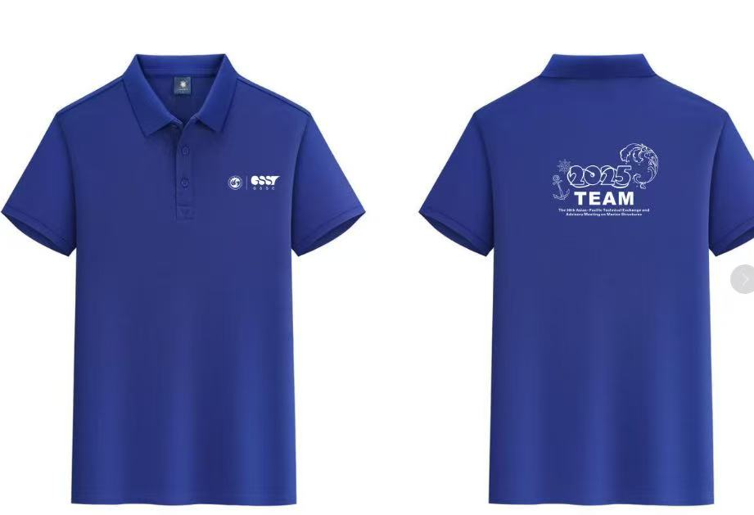

- Wuhan Tianhe International Airport (WUH)→ Conference Center, West Campus, Mafangshan Campus, Wuhan University of Technology
武汉天河国际机场→ 武汉理工大学马房山校区西院 会议中心
Recommended Route Link (推荐路线链接): https://surl.amap.com/giNUBtL1w9jM
Text Description:
· From Tianhe Airport Station (天河机场站), take Metro Line 2(towards Fozuling，佛祖岭方向) directly to Jiedaokou Station(街道口站). No transfers needed.
· After arriving at Jiedaokou Station:
For the Conference Center: Use Exit J（J口）and walk approximately 700 meters to Wuhan University of Technology, West Campus of Ma Fangshan(武汉理工马房山校区西院）
For Vienna International Hotel (Jiedaokou Branch): Use Exit L(L口）and walk approximately 500 meters to the hotel.
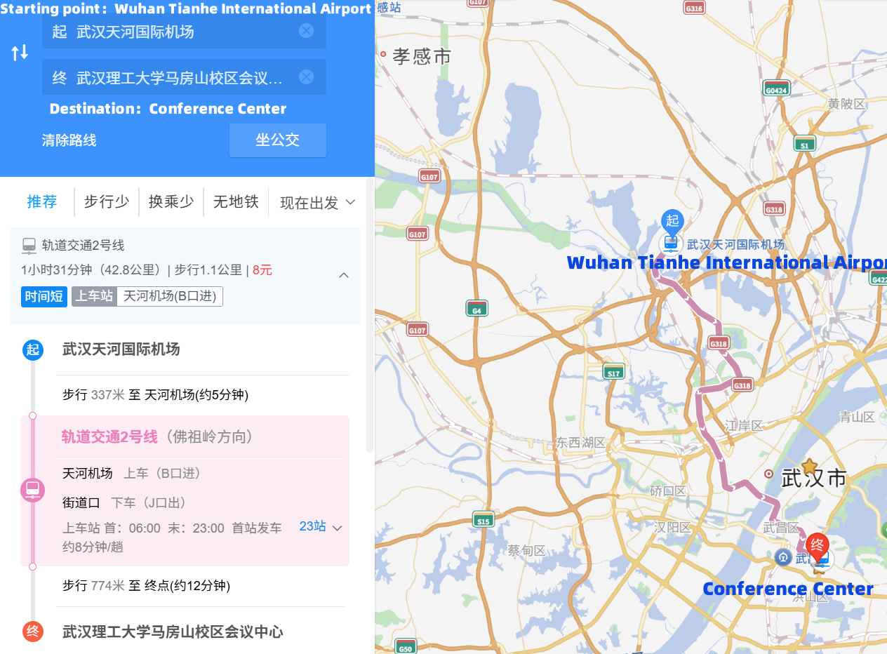
Estimated Time: ~1 hour 31 minutes (42.8km）
Ticket Cost: ~¥8

- Wuhan Railway Station → Conference Center, West Campus, Mafangshan Campus, Wuhan University of Technology
武汉站→ 武汉理工大学马房山校区西院 会议中心
Recommended Route Link (推荐路线链接): https://surl.amap.com/gZp9h6V1wcIA
Text Description:
·From Wuhan Railway Station (武汉站), take Metro Line 4 (Towards Qinglingju, 青菱方向) to Zhongnan Road Station (中南路站).
·At Zhongnan Road Station, transfer to Metro Line 2 (Towards Fozuling, 佛祖岭方向). Take Line 2 to Jiedaokou Station (街道口站).
·After arriving at Jiedaokou Station:
For the Conference Center: Use Exit J（J口）and walk approximately 700 meters to Wuhan University of Technology, West Campus of Ma Fangshan(武汉理工马房山校区西院）
For Vienna International Hotel (Jiedaokou Branch): Use Exit L(L口）and walk approximately 500 meters to the hotel.
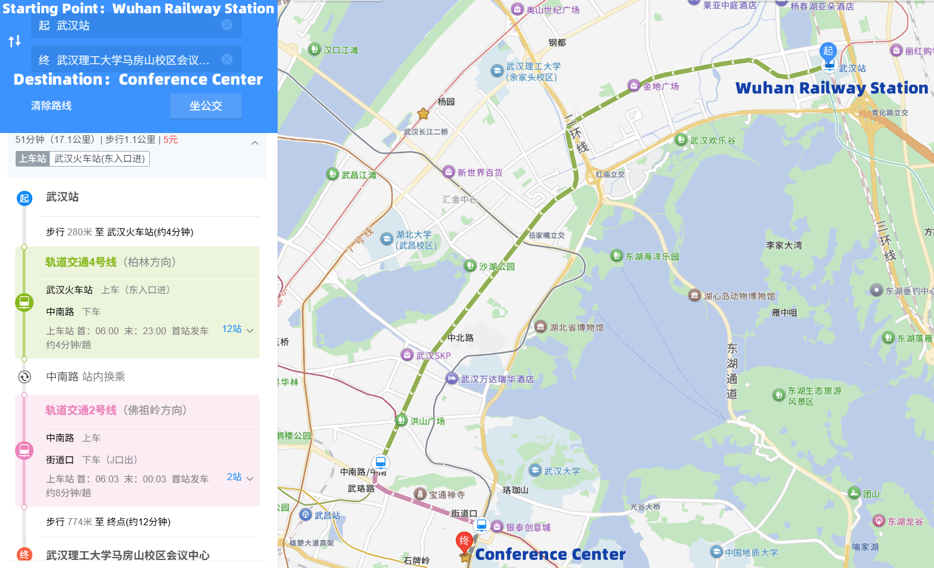
Estimated Time: ~51 minutes (17.1km）
Ticket Cost: ~¥5

- Hankou Railway Station → Conference Center, West Campus, Mafangshan Campus, Wuhan University of Technology
汉口站→ 武汉理工大学马房山校区西院 会议中心
Recommended Route Link (推荐路线链接): https://surl.amap.com/hf1qvsRP1hM
Text Description:
·From Hankou Railway Station (汉口站), take Metro Line 2 (Towards Fozuling, 佛祖岭方向) directly to Jiedaokou Station (街道口站). No transfers needed.
·After arriving at Jiedaokou Station:
For the Conference Center: Use Exit J（J口）and walk approximately 700 meters to Wuhan University of Technology, West Campus of Ma Fangshan(武汉理工马房山校区西院）
For Vienna International Hotel (Jiedaokou Branch): Use Exit L(L口）and walk approximately 500 meters to the hotel.
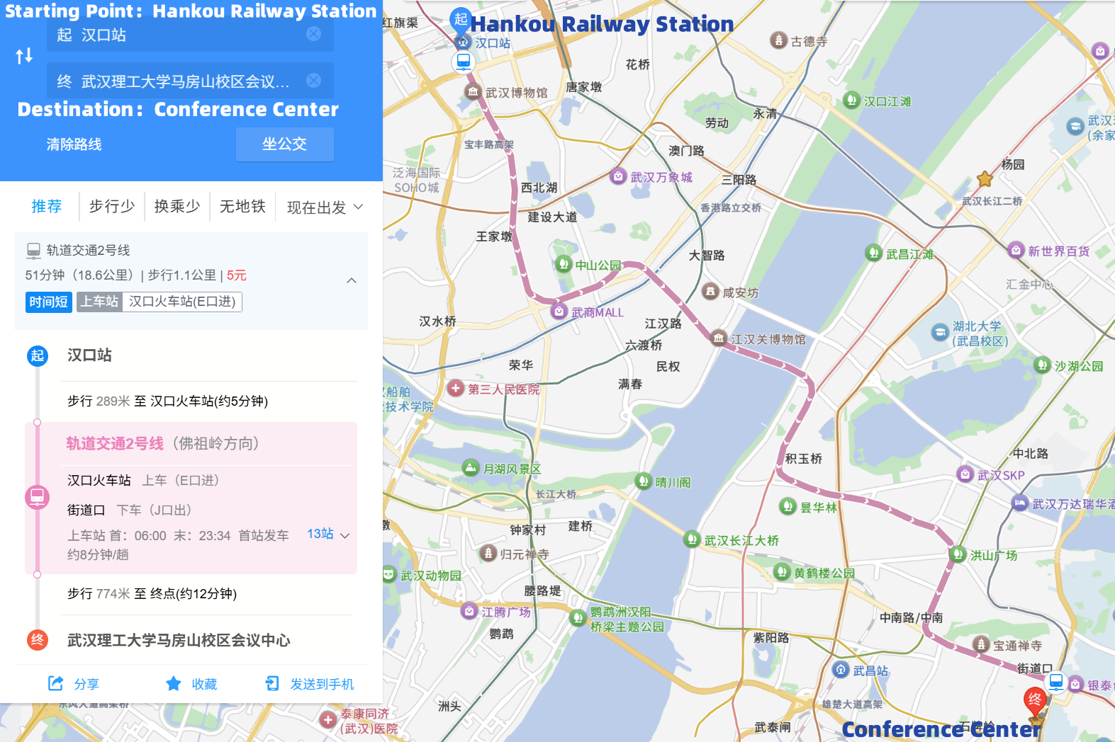
Estimated Time: ~51 minutes (18.6km）
Ticket Cost: ~¥5

- Wuchang Railway Station → Conference Center, West Campus, Mafangshan Campus, Wuhan University of Technology
武昌站→ 武汉理工大学马房山校区西院 会议中心
Recommended Route Link (推荐路线链接): https://surl.amap.com/hknc3DHvbgc
Text Description:
·From Wuchang Railway Station (武昌站), take Metro Line 4 (Towards Wuhan Railway Station, 武汉站方向) to Zhongnan Road Station (中南路站).
·At Zhongnan Road Station, transfer to Metro Line 2 (Towards Fozuling, 佛祖岭方向).Take Line 2 to Jiedaokou Station (街道口站).
·After arriving at Jiedaokou Station:
For the Conference Center: Use Exit J（J口）and walk approximately 700 meters to Wuhan University of Technology, West Campus of Ma Fangshan(武汉理工马房山校区西院）
For Vienna International Hotel (Jiedaokou Branch): Use Exit L(L口）and walk approximately 500 meters to the hotel.
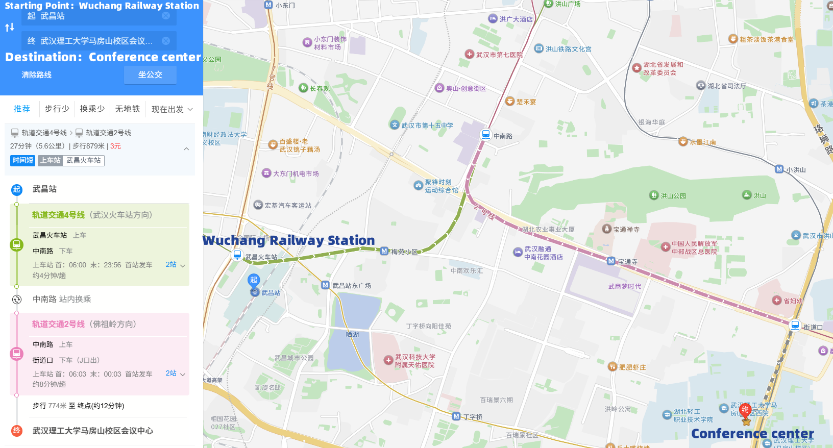
Estimated Time: ~27 minutes (5.6km）
Ticket Cost: ~¥3

- Wuhan East Railway Station → Conference Center, West Campus, Mafangshan Campus, Wuhan University of Technology
武汉东站→ 武汉理工大学马房山校区西院 会议中心
Recommended Route Link (推荐路线链接): https://surl.amap.com/hFBgQGds8Hn
Text Description:
·From Wuhan East Railway Station (武汉东站), take Metro Line 2 (Towards Tianhe Airport, 天河机场方向) directly to Jiedaokou Station (街道口站). No transfers needed.
·After arriving at Jiedaokou Station:
For the Conference Center: Use Exit J（J口）and walk approximately 700 meters to Wuhan University of Technology, West Campus of Ma Fangshan(武汉理工马房山校区西院）
For Vienna International Hotel (Jiedaokou Branch): Use Exit L(L口）and walk approximately 500 meters to the hotel.
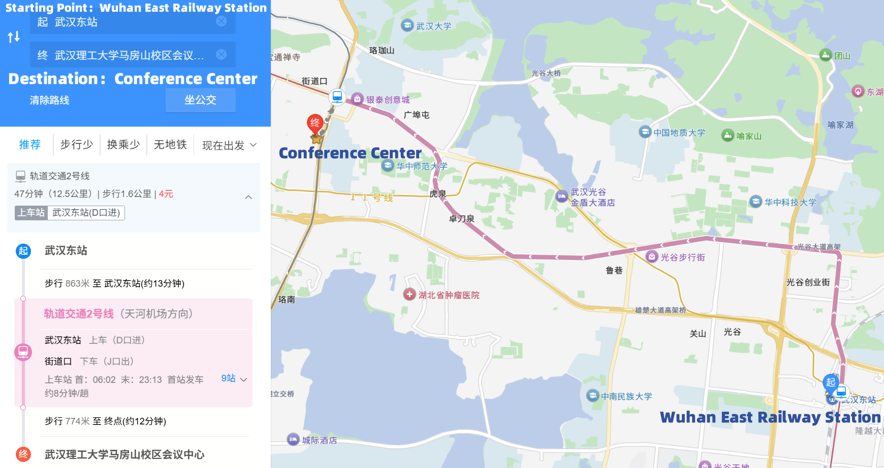
Estimated Time: ~47 minutes (12.5km）
Ticket Cost: ~¥4

Accommodation
The organizing committee has arranged hotel booking services at the Vienna Hotel for international attendees. Upon arrival, guests may pay for their stay in cash or by Visa card.
To make a reservation, please contact us in advance at team2025@whut.edu.cn to submit the booking form.
Domestic Chinese attendees are kindly requested to make their own hotel arrangements.
Email: team2025@whut.edu.cn
Conference Website: http://team2025.whut.edu.cn/

Vienna Hotel (Jiedaokou Branch)
Address: Block A, Incubation Building, Wuhan University of Technology,
No. 122 Luoshi Road, Hongshan District, Wuhan, Hubei Province

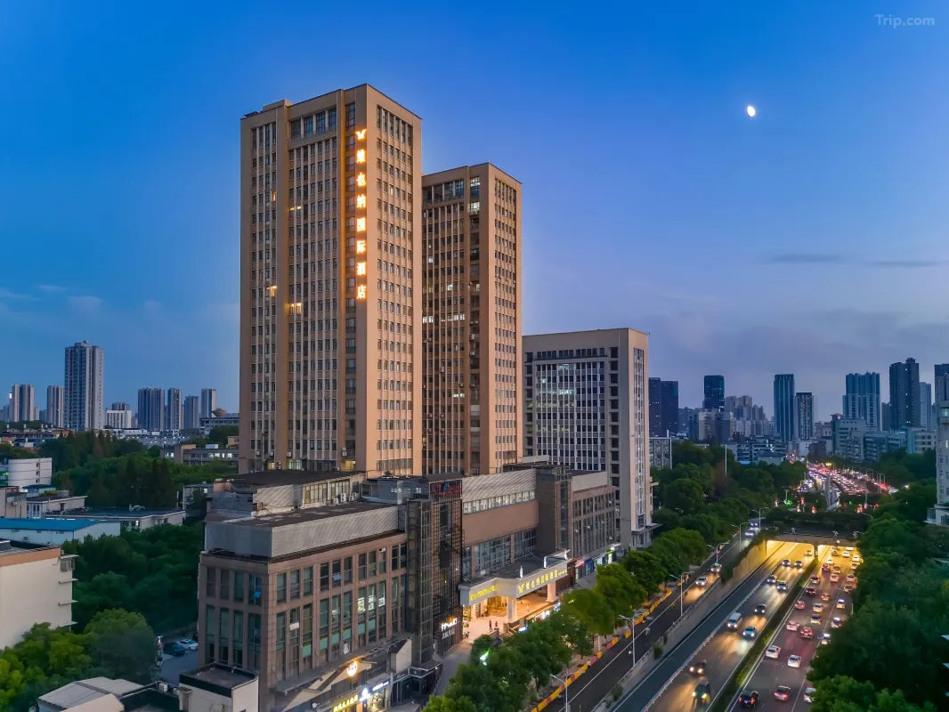
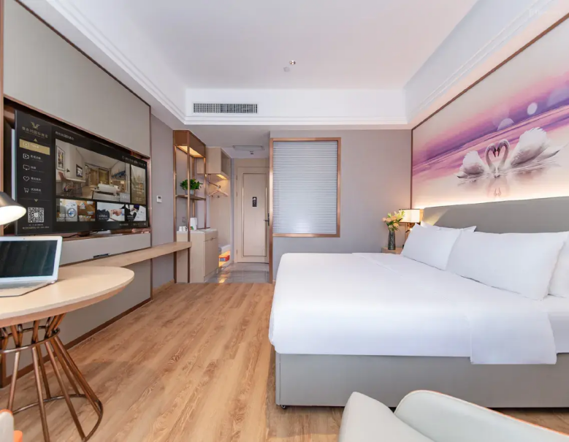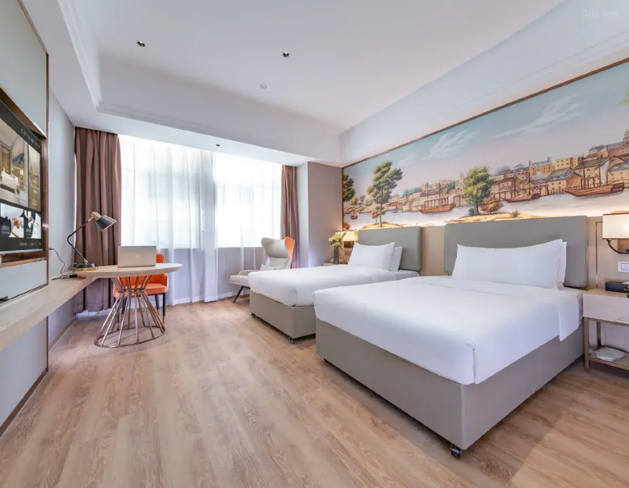

(“TEAM 2025” is necessary when check in)
Room Type（Price per night） | Room Area | Bed Type
King Room（350rmb） | 28–33 m² | 1 King-size bed, 2m*2m
Twin Room（350rmb） | 28–30 m² | 2 single beds, 1.2m*2m
* 5 minutes’ walk from the hotel to the conference center (TEAM 2025 conference site)

Please fill the following sheet and sent to TEAM 2025 Secretariat (team2025@whut.edu.cn).

Accommodation reserve sheet

Hotel | Vienna
Room type
Guest name
Remarks

* October is the tourist season. It is better to reserve hotel earlier.

Catering

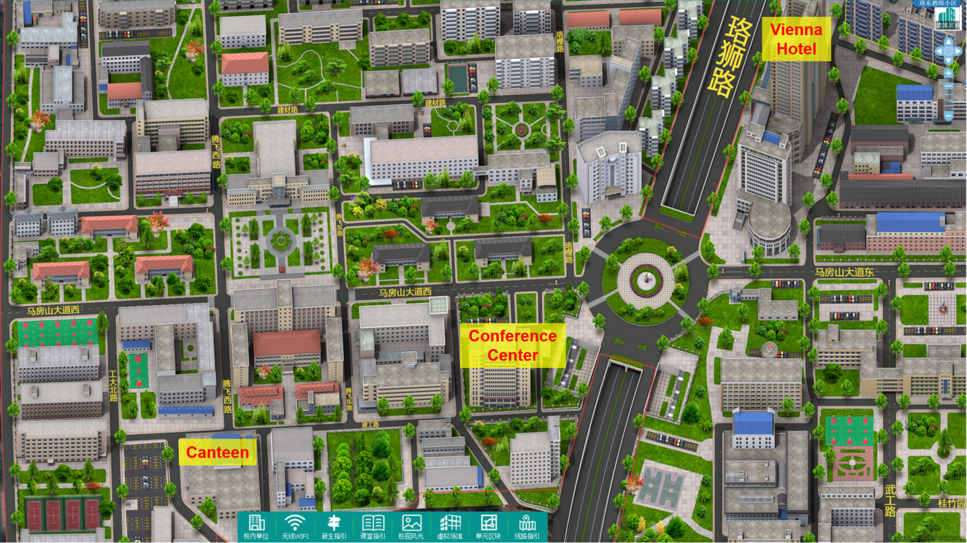

Sponsor Information

Exclusive Title Sponsor
Shandong New Energy Shipbuilding Co., Ltd.

https://en.sdxncy.com/

Gold Sponsor
Hubei Ansis New Energy Co., Ltd.20000

http://asunx.com/htm//web/home/index.html

Silver Sponsor
Wuhan University of Technology Shipbuilding Co., Ltd.

http://www.wutship.com/en/

Hubei Port Titanium Marine Technology Development Co., Ltd.


